- Overview

User information is stored in the assoc table. This function allows supervisors to maintain this information.

- Login Process

Before allowing the associate to perform user administration, the program must validate supervisor credentials via a login dialog box. In the current app, the window looks like this:

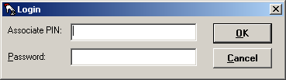

The user must provide a supervisor-level ID and password to access this functionality. The dialog box should display the Associate ID as it is being typed, but should display a series of asterisks for the keyed password.

If the associate keys in an invalid ID and/or password, the program should display a message such as “Login Not Valid – Please Try Again”, blank out the password field, and return the cursor to the Associate field.

If the ID and password are valid, but the security level is less than the Supervisor Level (defined in the configuration file), the program should display a message such as “You Must Have Supervisor Access To Use This Application”, blank out the password field, and return the cursor to the Associate field.

- Database Details

select assoc_security_lvl
from assoc
where assoc_id = <keyed ID>
and assoc_password = <keyed password>

- Associate Selection Screen

Once the supervisor has been validated, the program should display the “Associate Selection” window:

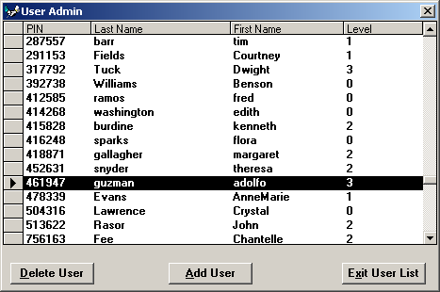

  - Database Details

select
assoc_id,
assoc_last_name,
assoc_first_name,
assoc_security_lvl,
assoc_middle_init, (not displayed)
assoc_passwd, (not displayed)
assoc_type (not displayed)
from assoc
order by assoc_id

All trailing spaces should be removed from the character fields.

- Adding An Associate

If the user clicks on the “Add User” button, the “Add Associate” window should be displayed:

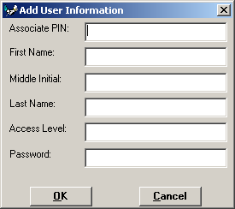

  - Database Details

insert into assoc (
assoc_id,
assoc_first_name,
assoc_middle_init,
assoc_last_name,
assoc_security_lvl,
assoc_passwd )
values (
:<keyed value>,
:<keyed value>,
:<keyed value>,
:<keyed value>,
:<keyed value>,
:<keyed value> );

  - Validation Details

The program should perform the following field checks prior to submitting the record for insertion:

assoc_id: Must be a six-digit number. Leading zeroes allowed.
assoc_last_name: Required. No case mapping.
assoc_first_name: Required. No case mapping.
assoc_middle_init: Optional.
assoc_passwd: 4-6 character alphanumeric. All uppercase letters mapped to lowercase.
assoc_security_lvl: numeric value between 0 and supervisor level (see config file)

If the user tries to create a record with an assoc_id that already exists, the program should display the error message “The Associate nnnnnn Already Exists, wait for user confirmation, then return to the ”Add Associate” screen.

- Editing An Associate

If within the Associate Selection screen the user double-clicks on a row, the program should open the “Edit Associate” window.

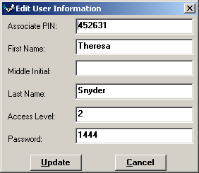

The program should populate the form with the row data previously selected in the Associate Selection screen.

  - Validation Details

The program should perform the same field checks as listed in the “Add Associate” logic above.

In addition, the program should record the “before” value for the assoc_id field. If the user changes this value, the program should determine if the new assoc_id value already exists in the table. If so, the program should display the message “The Associate nnnnnn Already Exists, wait for user confirmation, then return to the ”Edit Associate” screen.

If the update is successful, the program should close the edit screen, repopulate the Associate Selection window with the current information, and highlight the just-updated row.

- Deleting An Associate

If in the Associate Selection Screen the user highlights a user and clicks the “Delete User” screen, the program should do the following:

If the selected record is an associate who is currently logged into the system, then the program should display an error message stating “Cannot delete the account of an associate who is currently logged into the system”. Subsequently, the system should wait for the user to acknowledge the message and return control to the main User Admin window.

If the selected record has an assoc_type field containing the value ‘S’, the program should display the message “Cannot Delete A System User”, wait for user confirmation, then return control to the window.

Otherwise the program should ask Are You Sure? If the user clicks on the “No” button, the program should return control to the Associate Selection Window with the previously selected record still highlighted.

If the user clicks on the “Yes” button, the program should delete the selected record, and refresh the Associate Selection Window. At this point no rows should be highlighted.

- Exiting the Associate Selection Screen

In order to exit the Associate Selection Screen, the user should either click on the “Exit User List” button or kill the window using the window-termination symbol.

In either case, the program should return control to the main menu. This should include bringing it back up to the front, and doing the same with the store identification window (if it exists).

